Logarithmic Functions: Inverse of an Exponential Function

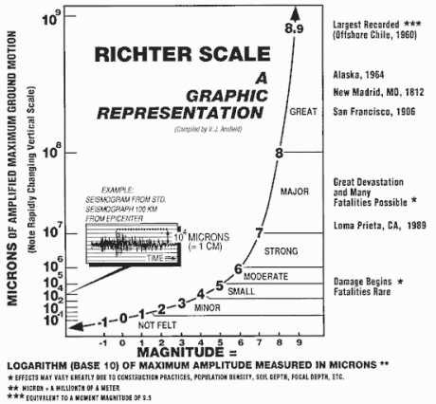
The Richter Scale

The magnitude of an earthquake is a measure of the amount of energy released at its source. The Richter scale is an exponential measure of earthquake magnitude, as shown on the right.
The magnitude increases per unit as the energy released increases by powers of ten.

A simpler way to examine the Richter Scale is shown below. An earthquake of magnitude 5 releases about 30 times as much energy as an earthquake of magnitude 4.
Energy Released: X 30
0
1
2
3
6
5
4
9
8
7
Magnitude: +1
E
E•30¹
E•30²
E•30³
E•30⁷
E•30⁶
E•30⁵
E•30⁴
E•30⁸
E•30⁹

In 1995, an earthquake in Mexico registered 8.0 on the Richter scale. In 2001, an earthquake of magnitude 6.8 shook Washington state. Let’s compare the amounts of energy released in the two earthquakes.

For the earthquake in Mexico at 8.0 on the Richter Scale, the energy released is E•30⁸ and for the earthquake in Washington state, the energy released is E•30^{6.8}. A ratio of the two quakes and using the properties of exponents yields the following:

Mexico earthquake E•30⁸ 30⁸
=
=
Washington earthquake E•30^{6.8} 30^{6.8}

30^{8-6.8} = 30^{1.2} ≈ 59.2

What this means is that the earthquake in Mexico released about 59 times as much energy as the earthquake in Washington. The exponents used by the Richter scale shown in the above example are called logarithms or logs.

A logarithm is defined as follows:

The logarithm base b of a positive number y is defined as follows:
If y = b^{x}, then log_{b}y = x.

The exponent x in the exponential expression b^{x} is the logarithm in the equation log_{b}y = x. The base b in b^{x} is the same as the base b in the logarithm. In both cases, b ≠ 1 and b > 0. So what this means is that you use logarithms to undo exponential expressions or equations and you use exponents to undo logarithms, which means that the operations are inverses of each other. Thus, an exponential function is the inverse of a logarithmic function and vice versa.

Key Features of Logarithmic Graphs
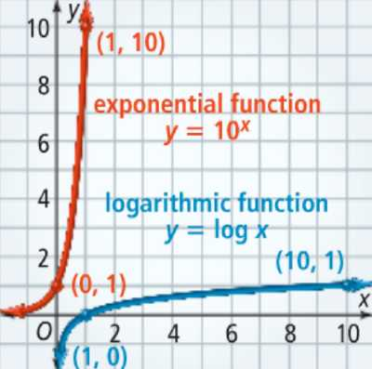
A logarithmic function is the inverse of an exponential function. The graph show y = 10^{x} and y = log x. Note that (0, 1) and (1,10) lie on the graph of y = 10^{x} and that (1, 0) and (10, 1) lie on the graph of y = log x, which demonstrates the reflection over the line y = x.

Since an exponential function y = b^{x} has an asymptote at y = 0, the inverse function y = log_{b}x has an asymptote at x = 0.

The other key features of exponential and logarithmic functions are summarized in the box below.

Key Features of Exponential and Logarithmic Functions
Characteristic | Exponential Function  y = b^{x} | Logarithmic Function  y = log_{b}x
Asymptote | y = 0 | x = 0
Domain | All real numbers | x> 0
Range | y > 0 | All real numbers
Intercept | (0,1) | (1,0)

Translations of logarithmic functions are very similar to those for other functions and are summarized in the table below.
Parent Function | y = log_{b}x
Shift up | y = log_{b}x + k
Shift down | y = log_{b}x - k
Shift left | y = log_{b}(x + h)
Shift right | y = log_{b}(x - h)
Combination Shift | y = log_{b}(x ± h) ± k
Reflect over the x-axis | y = -log_{b}x
Stretch vertically | y = a log_{b}x
Stretch horizontally | y = log_{b}ax

Let’s look at the following example.

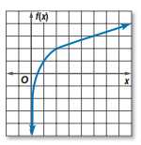

The graph on the right represents a transformation of the graph of
f(x) = 3 log₁₀ x + 1.
- |x| = 3: Stretches the graph vertically.
- h = 0: There is no horizontal shift.
- k = 1: The graph is translated 1 unit up.

