Sheldon’s Spot
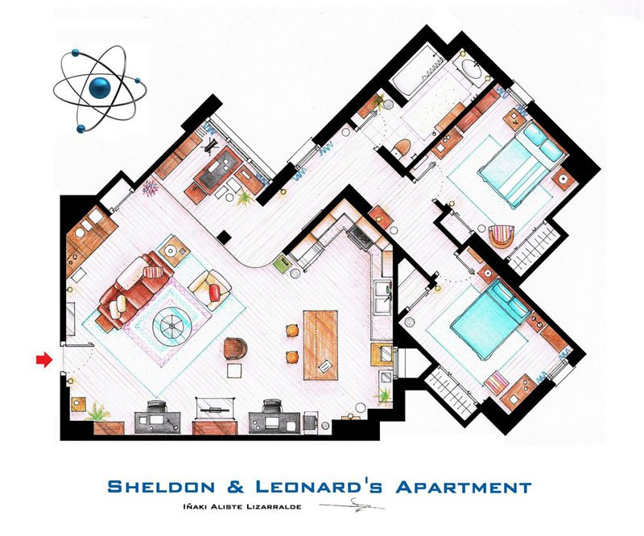
72° F
72° F
72° F
65° F
50° F
55° F
35°
55°
65°
90°
100°
15°

Calculate the Mean Radiant Temperature at Sheldon’s Spot. Show your work.

Leonard’s Spot
Z
72° F
72° F
72° F
65° F
50° F
55° F
15°
70°
25°
95°
80°
75°

Calculate the Mean Radiant Temperature at Leonard’s Spot. Show your work.

Howard’s Spot
Z
72° F
72° F
72° F
65° F
50° F
55° F
48°
40°
15°
140°
92°
25°

Calculate the Mean Radiant Temperature at Howard’s Spot. Show your work.

Koothrappali’s Spot
Z
72° F
72° F
72° F
65° F
50° F
55° F
20°
60°
50°
120°
100°
10°

Calculate the Mean Radiant Temperature at Koothrappali’s Spot. Show your work.

Penny’s Spot
Z
72° F
72° F
72° F
65° F
50° F
55° F
10°
90°
70°
125°
45°
20°

Calculate the Mean Radiant Temperature at Penny’s Spot. Show your work.

Amy’s Spot
Z
72° F
72° F
72° F
65° F
50° F
55° F
60°
113°
92°
43°
22°
30°
55°

Calculate the Mean Radiant Temperature at Amy’s Spot. Show your work.

Bernadette’s Spot
Z
72° F
72° F
72° F
65° F
50° F
55° F
51°
42°
21°
127°
91°
28°
55°

Calculate the Mean Radiant Temperature at Bernadette’s Spot. Show your work.

